MIP PKG 12 - UTILITIES, FLARE AND PIPERACK FOR TANAJIB GAS PLANT PROJECT

Contractor No. 6600044614 (OOK) / 6600044615 (IK)
BI No. 10-09003

SOUND COVERAGE STUDY FOR
EMERGENGY SIREN SYSTEM

TABLE OF CONTENTS

1. Introduction 3
1.1 Project Description 3
1.2 Purpose of this document 3

2. Sound simulation 3
2.1 Simulation Software, EASE 3
2.2 Procedure 4
2.3 dB, dB(A) and dB(C) 4
2.4 Calculation of Attenuation 5
2.5 Sound pressure level 6

3. evaluation 7
3.1 Performance Requirement 7
3.2 Assumptions 8

4. Conclustion 8

Appendix
A. Stepwise Procedure of EASE Simulation 9
A-1. Procedure 9
B. Speaker Information 13
B-1. MOD8032B (Federal Signal) for Emergency Siren System 13
B-1-1. Datasheet 13
B-1-2. Polar Pattern Graph 14
B-1-3. SPL vs Frequency Graph 14
C. Simulation Detail 15
C-1. Ambient Noise Map - Emergency Siren System Outdoor Areas 16
C-2. Sound Press Level Map(SPL) - Emergency Siren System Outdoor Areas 17

Introduction

Project Description
Marjan offshore oil field is in the Arabian Gulf, about 85 kilometers northeast of Tanajib. Marjan Field Development Program is an integrated development for oil and gas including production of associated gas, gas cap and non-associated gas from field reservoirs. The purpose of the new facilities under the Program is to support the corporate strategy to produce 800 MBCD of Arabian Medium crude oil from Marjan field which will also produce approximately 1800 MMSCFD of additional gas.

Purpose of this document
The main purpose of this document is to analyze sound coverage in order to confirm position and number of the speakers for "Emergency Siren System" in the Tanajib Gas Plant (TGP), Tanajib, Saudi Arabia.

Sound simulation

Simulation Software, EASE

AFMG's a PC-based Sound Simulation Software EASE is an abbreviation of Enhanced Acoustic Simulation for Engineer, it was developed by Wolfgang Ahnert who is the Sound physicist. The most widely used of the PC-based Sound Simulation Software EASE starts from early DOS version, has improved consistently for 30 years and now operates in the Microsoft Window based.

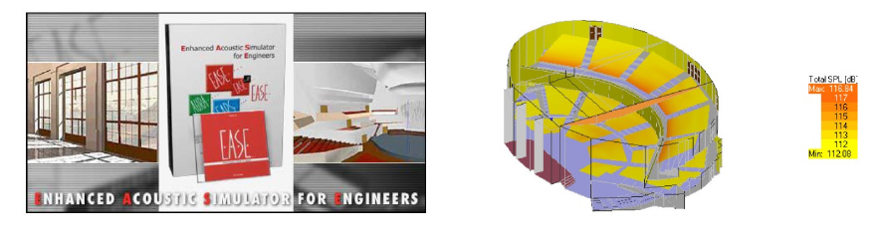
Figure 1

Acoustic line tracking method of the EASE program algorithm (Raytracing Method Algorithm) will perform the functions as follows:

- Architectural Space Settings
- Speaker Placement
- Speaker-oriented architectural space in each
- Sound pressure distribution (total pressure, direct sound, reflections) prediction
- Clearness index prediction: RASTI, ALCONS etc.

Procedure
A stepwise procedure of simulation is shown in Appendix A

dB, dB(A) and dB(C)

In general, sound level is expressed in dB while noise level is expressed in dB(C) that is C-weighted value. dB(C) is usually used for Peak measurements and also in some entertainment noise measurement, where the transmission of bass noise can be a problem.

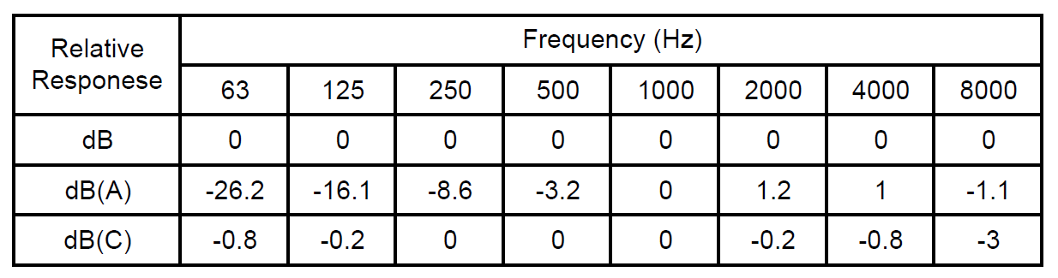
Figure 2

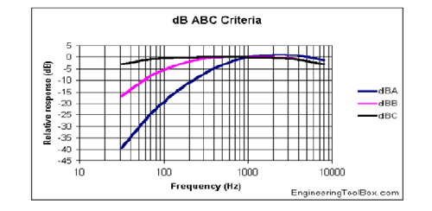
Figure 3

The main contribution of the plant noise is concentrated at the frequencies below 500Hz. The simulated loudspeaker coverage will be calculated in dB unit at the center frequency of 1000Hz of one octave band where no weighting factor is applied. This makes dB and dB(C) levels equalized. Also this is for the practicability of evaluation of alarm sound levels that has the focused sound energy at 1000Hz.

Calculation of Attenuation
Sound level attenuation ($L_{P}$) is calculated using the following formula.
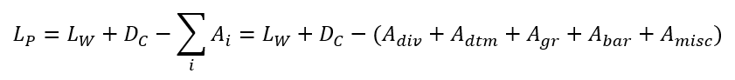

Where:
- Lw is the sound power level produced by each loudspeaker;
- Dc is the loudspeaker directivity correction;
- Ai are the noise attenuations term.

The attenuation terms are evaluated as follow:
- Adiv: geometrical divergence for spherical spreading in the free field from a point source;
- Aatm: when a sound wave propagates in the atmosphere, the effects of viscosity and turbulence lead to absorption of the sound by the air; this absorption is a function of temperature and humidity of the air, and increase as the frequency of sound waves increases; this term is evaluated in accordance to ISO 9613-I:1993
- Agr: ground attenuation is mainly the result of sound reflected by the ground surface interfering with the sound propagation directly from source to receivers;
- Abar: attenuation caused by diffraction phenomena;
- Amisc: attenuation due to miscellaneous other effects, for example due to passage of sound wave through a group of obstacles.

Sometimes for the ease of calculation the value of (Aatm + Aground + Adiffr + Ab) is estimated as 1dB, but EASE uses Image Source Method and Ray Tracing Method to calculate reflections based on the absorption coefficients of wall materials. Diffraction is marginal hence it is neglected in EASE simulation. Overall the difference between the 1dB estimation and the EASE calculation of reflections is expected less than 0.5dB.

Sound Pressure Level (SPL)

All loudspeaker data sheets should quote the Sound Pressure Level of the loudspeaker measured in decibels (dB). This is the sensitivity of the loudspeaker and is normally quoted at a distance of (1 meter) with a speaker tapped at (1 watt).

The SPL figure provides a standard from which coverage of a given loudspeaker location can be calculated. The increase or decrease in Sound Pressure Level for various levels of power input compared with the SPL for an input of one watt obeys a square law and can be calculated using the following formula:

𝑑𝐵 = 10 𝑙𝑜𝑔 𝑃𝑥

Where: 𝑃𝑥 = Power level for which the change in output level is being calculated The basic rule is that each time the power input to the loudspeaker is doubled the output level is increased by 3 dB. For example, a loudspeaker having an SPL of 90 dB (for 1W/1M) will have an output of 93 dB for 2 watts, 96 dB for 4 watts etc.

The decrease in Sound Pressure Level compared with the SPL at a distance of 1 meter obeys an inverse square law and can be calculated using the following formula:

𝑑𝐵 = 20 𝑙𝑜𝑔 𝐷𝑥

Where: 𝐷𝑥 = Distance at which the change in output level is being calculated The basic rule is that each time the distance is doubled; the sound level will decrease by 6dB. For example, if the output level of a loudspeaker is 90 dB at 1 meter, at 2 meters it will be 84 dB, at 4 meters it will be 78 dB etc. The formula for Sound Pressure Level for a point source (S) in a free field is:

𝐿p = 𝐿w −10 log (4𝜋𝑅^2)

Where: 𝐿p = 𝑆𝑜𝑢𝑛𝑑 𝑃𝑟𝑒𝑠𝑠𝑢𝑟𝑒 𝐿𝑒𝑣𝑒𝑙 (𝑆𝑃𝐿)

𝐿w = 𝑆𝑜𝑢𝑛𝑑 𝑃𝑜𝑤𝑒𝑟

Figure 4

Evaluation

Performance Requirement
Volume of the loudspeakers for an area shall conform to the following for minimum sound pressure levels.

- The minimum sound pressure levels for broadcasting emergency announcement.

- A sound level of 105 dBA shall not be exceeded at grade or where personnel are normally present.

- Minimum alerting sound level in the coverage area shall be 15 dB above average ambient sound level.

- Determine the suitability of the SPL values by comparing them with noise levels.

- Sounders shall be capable of generating alert tones from 115 to 125 dBC measured at 30 meters and in the range of 200 to 1,500Hz.

Assumptions
The study has been developed following the assumptions listed below:

All maps represent SPL at 1.5 meter above each deck floor.

In the case of outdoor doors 3D modelling, only buildings were considered as obstacles, and the height of the building shall be 6 meters.

All speakers are installed at a height of 15m from finished floor level.

The speakers applied to each system are as follows.
- External loudspeakers of the Emergency Siren System are 3200W "MOD8032B" provided by Federal Signal, and the data sheet and polar pattern graphs are shown in Appendix B.

EASE software does not support the function of set up the ambient noise for each Area. So, the average of the ambient noise list was applied to the simulation.
According to above mention, the ambient noise for outdoor use in this simulation will set in Appendix C.

conclusion
As evident from calculation result of Appendix C, average noise is 80dBc and maximum value of SPL is 123.01 dBC, the average SPL value is 99.32 dBC. And also, the sounder generates 118dBC in 1000Hz when measured at 30m.
Therefore, analyzing from the above result, the SPL value is higher than the noise value. It means that the location and the number of speakers are considered properly.

